***TCW-ServicePro Support History***

| **Document Revision History** | | |
| --- | --- | --- |
| Date | Details | Updated By |
| Sept 2016 | First documentation (Till Priority Set-type enhancement) | Harshitha |
| Dec 2016 | Support with installing older version of QA documented | Harshitha |
| Oct 2017 | Fixing app compatibility issue with iOS11 documented | Harshitha |
|  |  |  |

**9 Jul,2015 :**

Updated iPad’s iOS version to 8.4, tested app’s compatibility with it.

**15 Jul,2015 :**

Issue : TCWServicepro24 provisioning profile was about to expire.

Fix : Renewed the profile on Apple Developer portal,and used it in the project code. Built a new ipa with the renewed profile, tested it on iPad, and uploaded the profile and build to the download portal.

**15 Sept,2016 :**

Requirement : To be able to modify Priority (set type) on detail screen.

Enhancement process :

Prior to the enhancement, Priority was a display only field, Set-type was housed in the Priority field; Set Type & Set Type description fields were separate display only fields within the "Other Details" block, before the "Service Item" section.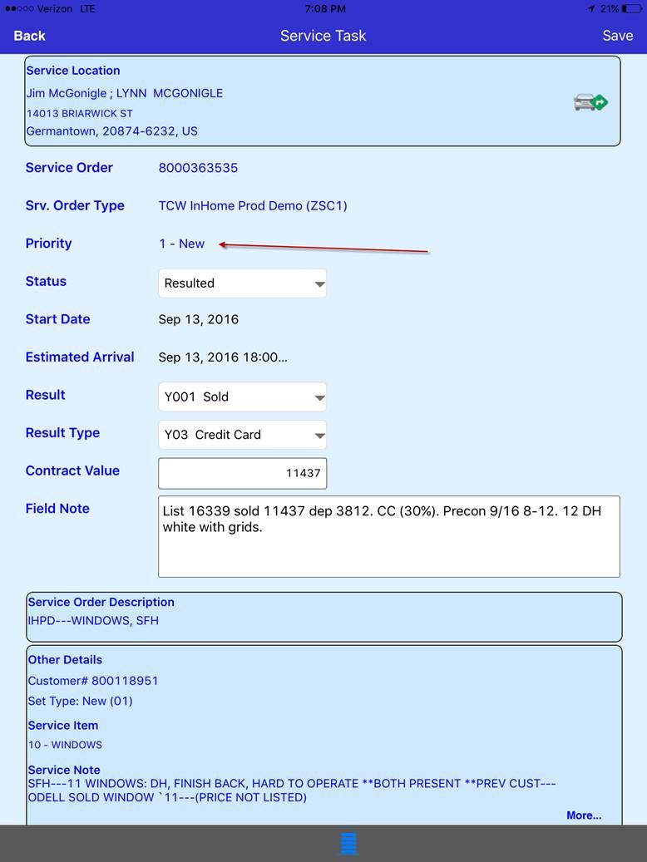

With the enhancement, to avoid confusion, Priority field was dropped from the ServicePro detail screen, and Set Type field was provided on ServicePro as a new editable field (with a list of specific possible values).

ZZSETTYPE and ZZSETTYPE_TXT fields of YTCCSMST_SRVCDCMNT10 table resulting from the SERVICE-DOX-FOR-EMPLY-BP-GET api call form the Priority field.

ZZSETTYPE and ZZSETTYPE_TXT fields of ZTCCST_SETTYPET table resulting from the SERVICE-DOX-CONTEXT-DATA-GET api call form the list of possible values for the Priority field.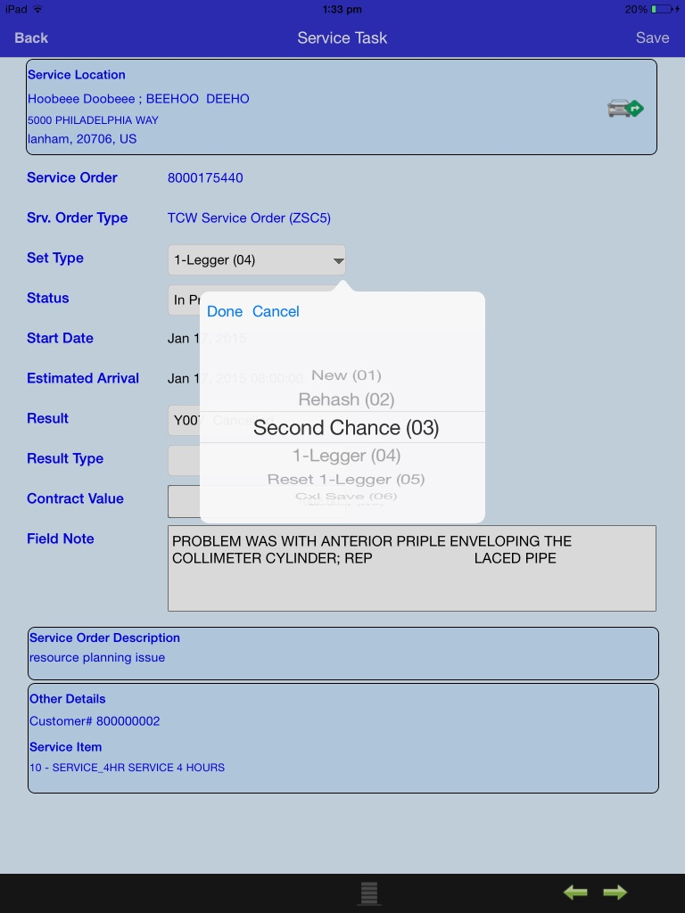

These changes were made to the QA version of the application. In order to create a new build with these modifications, the private and public keys of the certificate that was currently being used were lost. Hence, a new "In-House and Ad Hoc” certificate named “iPhone Distribution: Thompson Creek Window Company” was created. App ID named “com.tcw.gssServicepro” and an “Ad Hoc" provisioning profile named “TCWServiceproProvisioningprofile” complying with the newly created certificated were created. Using these newly created certificate and profile, new build was generated and uploaded to the download portal for client’s validation.

Post the validation and approval to the SetType enhancements of the QA version by the client, client preferred the app upgrade to facilitate in groups when the enhancements are moved to Production. To provide app upgrade in phases across different groups of users, the ServicePro component version on the CRM system was enhanced to avoid impact on the data update (in particular with the Set Type) resulting from a mismatch between Mobile App version and the ServicePro component version on the CRM system.

Two QA versions were uploaded to the download portal :

* The latest version with the editable Set-Type enhancement.
* The older version (as of 15 Jul. 2015) without the editable Set-Type field.

Because of the planned phased roll-out of the enhanced version of the app, client was requested to validate the older version of the app to check its impact (if any) from the Set-Type related enhancement to the users with the currently productive  
version of the app.

Installation of the older version of ServicePro(QA), both through OTA and iTunes failed because the older ipa shared on 15 Jul. 2015 was re-shared on the portal for installation and validation, which was created using “TCWServicepro24” provisioning profile and had expired.

To support installation of this old build, renewed “TCWServicepro24” profile had to be installed on the iPad which isn’t supported anymore through iTunes,and has to be done using Xcode, which is not feasible for the client. Hence, a fresh build was created for the old code(without SetType enhancement) using new “iPhone Distribution: Thompson Creek Window Company” certificate and “TCWServiceproProvisioningprofile” provisioning profile, and was shared on the download portal for client’s validation.

Upon client's validations, the enhancements were moved to the Production environment. Build was created including the enhancements for Production version and uploaded onto the download portal for OTA app installation.

**2 Aug,2017 :**

Issue : Certificate used for ServicePro was revoked by another developer our client had, which resulted in app not opening on all devices.

Fix : Created a new certificate, Apple ID and a provisioning profile on the Apple developer portal for the app. Used the same to create a new build,validated the app and uploaded the IPA onto the download portal for client installation.

**17 Oct,2017 :**

Issue : App not opening on iPads upgraded to iOS11.

Fix : As support to 32-bit app was not available with iOS11 update, apps weren’t opening. App architecture was upgraded from 32-bit to 64-bit to make them compatible with iOS11. Under Project - > Build settings - > Architectures - > Valid architectures, “arm64” was added to support 64-bit architecture. Currently Valid architectures contains “armv7 armv7s arm64”.

Added “Privacy - Camera usage description”, ”Privacy - Location usage description”, “Privacy - Location always usage description” and “Privacy - Location when in use usage description” under ServicePro-Info.plist to avoid camera and location fetch framework crash.